**In JS we have some handy Important features for functions**

**Default argument**

We can set default argument in case arguments aren’t supplied during function call

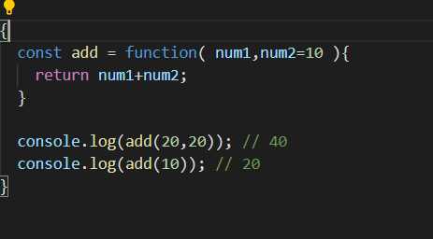

**The argument Object**

argument, object is available inside every function.

It has got some really interesting methods for us

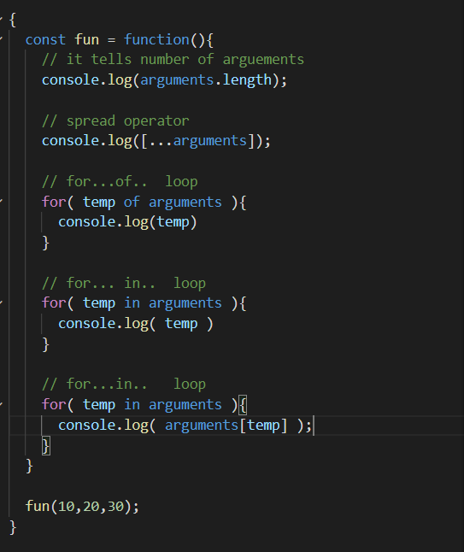

Actually, in arguments object are numbers starting from zero and values are our passed arguments

See

